Balanced Portfolios
A traditional portfolio is a portfolio that contains both stocks and bonds. At what percentages? This depends on many factors like your current age, retirement age, your risk tolerance, etc.
Mohsen Hassan advice: if you are to invest in a fund that consists of stocks and funds, he recommends Vanguard rather than banks because Vanguard has small fees compared to banks (e.g. Royal Bank of Canada) funds. Usually, traditional portfolios diversify between stocks and bonds in 80/20, 60/40, or 40/60 percentages. Search for “balanced funds” on Vanguard for more information.
Let’s compare the performance of the following portfolios:
- All-stocks portfolio (SPY).
- 80% stocks (SPY) and 20% bonds (BND) portfolio 1.
- 20% stocks (SPY) and 80% bonds (BND) portfolio 2.
- All-bond portfolio (BND) portfolio 3.
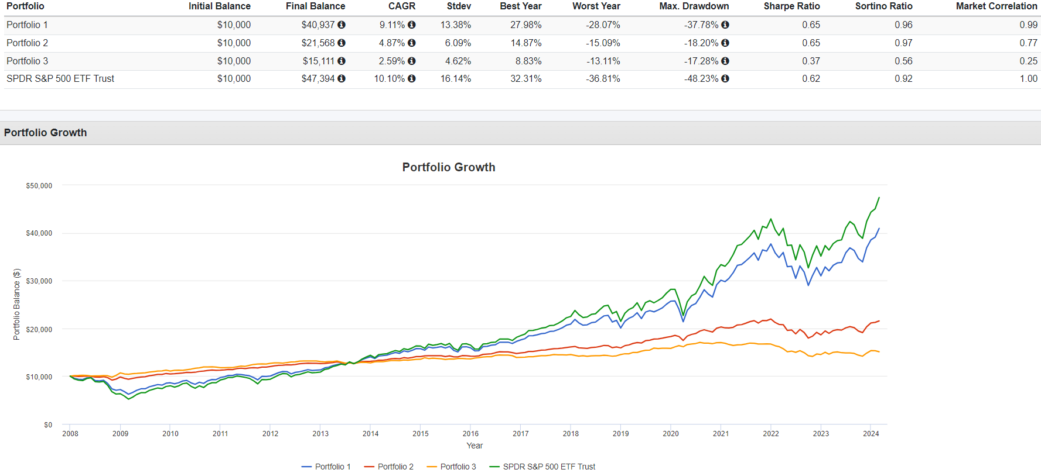
Some important, yet expected observations:
- On the long run, the all-stocks portfolio (green) outperforms all portfolios containing bonds with an average annual profit of 10.1%. However, it has the highest volatility with a standard deviation of 16.14%.
- The all-bond portfolio has the least return with an average annual profit of 2.59%, but it has the least volatility of 4.62%.
- The all-stocks portfolio has an average annual profit and volatility of 10.1% and 16.14%, respectively, compared to 9.11% and 13.38%, respectively, in case of the 80%-stocks-20%-bonds portfolio. Thus, by adding only 20% bonds to your portfolio, you decreased your profit by ~1% for a risk reduction of ~3%.
- After the 2008 financial crisis and 2020 pandemic, the all-stocks portfolio was the most affected, while the all-bond was the least affected. However, the all-stocks portfolio recovered way higher.
This is why it is always advised that: the younger you are, the more you should add stocks to your portfolio because you still have time to recover BETTER from the stock market volatility. As you get older, you should begin adding bonds to your portfolio.

Asset Allocation by Age
  - Formula 1
$$\% of Bonds=Age$$
Example: at age 30: 70% stocks - 30% bonds.
  - Formula 2
$$\% of Bonds=\left(Age-40\right)×2 (and zero out if negative)$$
Example: at age 30: 100% stocks – 0%
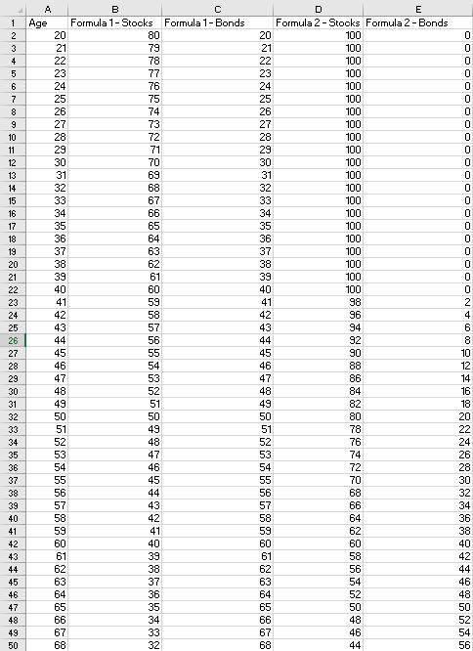
Notice that formula 1 tells you to invest in bonds at very young age. Imagine at the age of 25, your portfolio is 75% stocks and 25% bonds, too much bond percentage at a young age! This is why the second formula is more preferred because it tells you to invest in bonds only after 40.
These formulae are just to help you; you don’t need to stick to them. For example, if someone has bad health or not expected to have long life should invest more in bonds.

Rebalancing Benefits
Assume your portfolio is 60% stocks and 40% bonds. If a market crash happened, stocks would go down and bonds would almost remain fixed. Accordingly, your portfolio’s allocation would shift, it might become 30% stocks and 70% bonds. So, you rebalance by selling some bonds (that didn’t drop) to buy some more stocks (that dropped) so that you bring the ratio back to 60% stocks and 40% bonds. Now, the stock market will pick up after the market crash and soon it will outperform the bonds that the ratio becomes, for example, 80% stocks and 20% bonds. So, you rebalance to bring it back 60% stocks and 40% bonds. Now, assume another market crash occurs, so the ratio shifts to 30% stocks and 70% bonds, and so on the cycle keeps repeating. So, notice the benefits of rebalancing:
- If you haven’t rebalanced after the market crash and left the ratio 30% stocks and 70% bonds as it is, you wouldn’t have benefited from the big boost the market will have after the crash.
- If you haven’t rebalanced before the market crash and left the ratio 80% stocks and 20% bonds, you would have suffered a larger loss when the market crashed.
However, notice that this would be beneficial only if there is an upcoming market crash. If the market crash never crashes, it is better to leave the stocks get bigger and bigger in your portfolio.

Security Selection Benefits
El a7san tshoof el video, bs howa el kalam raye7 fi seket enak fel a5er it is good to be active in buying and selling bonds such that enak teshtery US long-term government bonds fel aw2at el fiha interest rates 3alya, w tebee3 lama el interest rates teb2a olayela.

Tactical Asset Allocation Benefits
Watch the lecture

